**PERSONAL BLOG ON IBM CLOUD STATIC WEB APPS**

**PHASE 2 PROJECT:**

**OBJECTIVES:**

The objectives of hosting a personal blog on IBM Cloud using Static Web Apps can vary depending on your individual goals and interests. However, here are some common objectives for creating and hosting a personal blog:

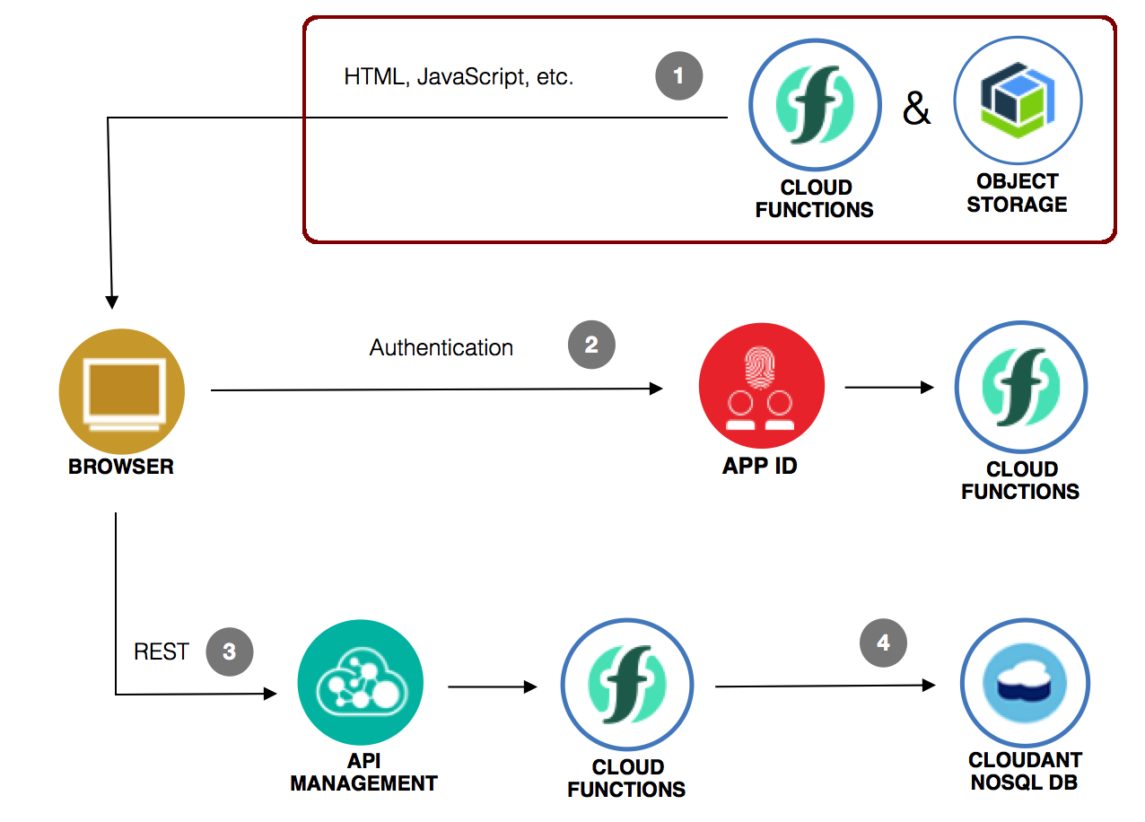

**1. Share Knowledge and Expertise:**

Many people create personal blogs to share their knowledge, expertise, and experiences on specific topics or industries. Your objective might be to contribute valuable information to a particular niche or field.

**2.Build an Online Presence:**

Hosting a personal blog allows you to establish and enhance your online presence. It's a way to showcase your skills, personality, and interests to a global audience.

**3.Document Personal Journey:**

Some bloggers use their websites as a digital diary to document their personal journey, growth, or life experiences. The objective is to reflect on and share their experiences with others.

**4.Express Creativity:**

For creative individuals, a blog serves as a platform to express their creativity. Whether it's through writing, photography, art, or multimedia content, the goal is to showcase their creative talents.

**5.Promote a Cause or Passion:**

If you are passionate about a particular cause, hobby, or interest, a blog can be a means to promote and advocate for that cause. The objective is to raise awareness and engage with like-minded individuals.

**6.Monetize and Generate Income:**

Some bloggers aim to generate income from their blogs through various monetization strategies, such as affiliate marketing, sponsored content, or selling products/services. The objective is to create a revenue stream.

**7. Enhance Professional Portfolio:**

If you have a professional or business objective, a personal blog can serve as an extension of your portfolio. It can showcase your work, achievements, and skills to potential employers or clients.

**8.Educate and Inform:**

Your goal might be to educate and inform your audience about specific topics, industries, or trends. You may want to provide tutorials, guides, or how-to content.

**9.Improve Writing and Communication Skills:**

Blogging can be a means to improve your writing and communication skills. The objective is to become a better writer and communicator over time.

**10.Network and Connect:**

Building a community around your blog is a common objective. You may want to connect with like-minded individuals, engage in discussions, and expand your network.

**11.Track and Measure Progress:**

Set objectives for your blog's growth, such as increasing traffic, engagement, or social media followers. Use analytics tools to track and measure your progress toward these goals.

**12.Personal Branding:**

Establishing a personal brand is essential for some bloggers. The objective is to create a unique online identity and reputation that resonates with your target audience.

**Creating a personal blog on IBM Cloud using Static Web Apps involves several steps. Here's a high-level overview of the process:**

**1.Sign Up for IBM Cloud:**

If you haven't already, sign up for an IBM Cloud account.

**2.Install Required Tools:**

Ensure that you have the necessary tools installed, including Git for version control and the IBM Cloud CLI for managing your cloud resources.

**3.Monitor and Scale (Optional):**

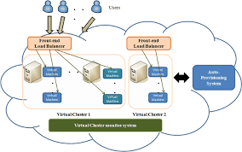

Use IBM Cloud monitoring tools to keep an eye on your blog's performance and scalability. You can adjust resources if needed.

**4.Create a GitHub Repository:**

Create a GitHub repository to host your blog's source code. Initialize the repository with your blog content, such as HTML, CSS, and JavaScript files. You can use static site generators like Jekyll or Hugo if you prefer.

**5.Configure Your Blog:**

Set up the necessary configuration files, such as a `README.md`, `index.html`, `styles.css`, and any other assets required for your blog.

**6.Push to GitHub:**

Commit your changes to your GitHub repository and push them to the remote repository.

**7.Create an IBM Cloud Static Web App:**

Now, it's time to create a Static Web App on IBM Cloud:

* Log in to your IBM Cloud account using the IBM Cloud CLI.
* Run the command to create a new Static Web App, specifying your GitHub repository as the source.

```bash

ibmcloud resource service-instance-create <service-instance-name> <service-plan> <region>

ibmcloud resource service-instance-update <service-instance-name> -p '{"github_repo_url": "<your-github-repo-url>"}' ```

* Follow the prompts to configure your Static Web App, including selecting a region, defining build settings, and specifying the deployment branch.

**8.Deploy Your Blog:**

Trigger the deployment of your blog by pushing changes to the specified deployment branch in your GitHub repository. The Static Web App service on IBM Cloud will automatically build and deploy your site.

**9.Secure Your Blog (Optional):**

Implement security best practices, such as enabling HTTPS, to protect your blog and user data.

**10.Regular Maintenance:**

Regularly update your blog with new content and make any necessary updates or improvements.

**11.Test Your Blog:**

Once your blog is deployed, test it to ensure everything is working as expected.

**12.Backup and Disaster Recovery (Optional):**

Implement backup and disaster recovery plans to protect your data and content.

**13.Configure Custom Domain (Optional):**

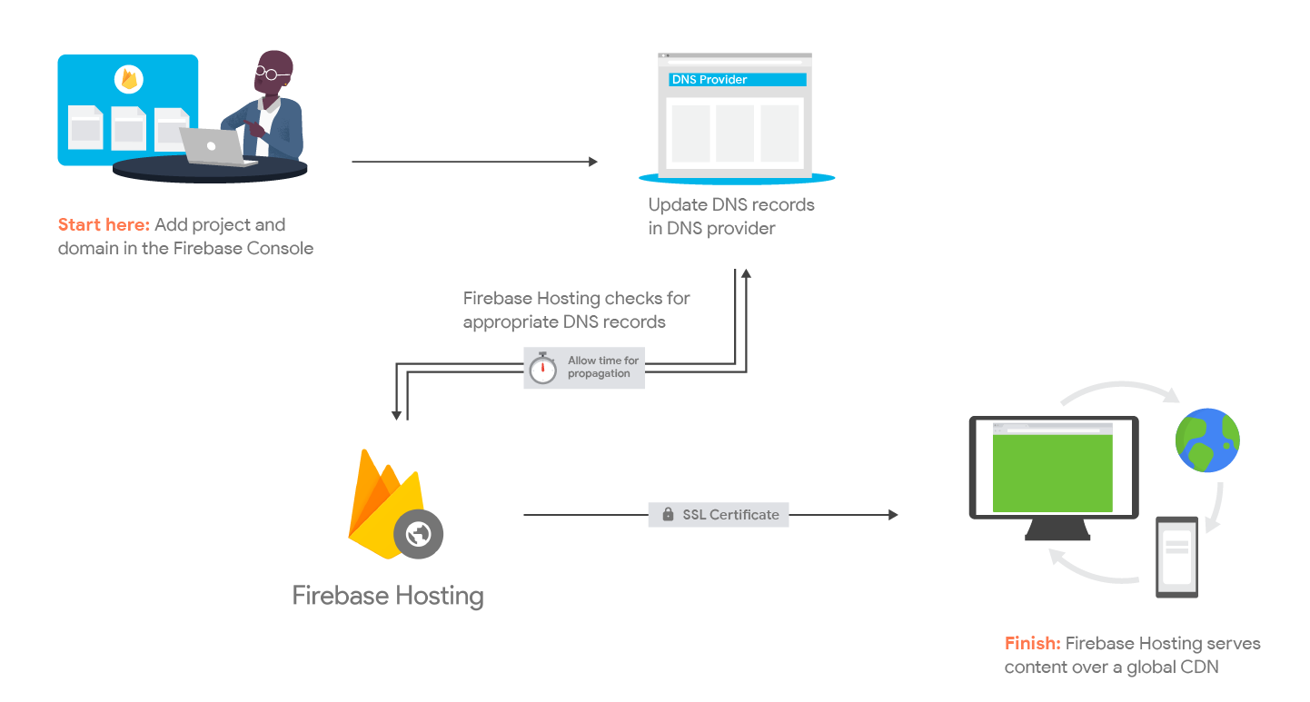

If you have a custom domain, you can configure it to point to your IBM Cloud Static Web App by updating your domain's DNS settings.

**CONCLUSION:**

Remember to consult IBM Cloud documentation for specific details and commands related to the services and features you're using. Additionally, consider your specific requirements and any additional features you want to add to your personal blog to tailor these steps accordingly.

**Presented by,**

K.Rajeshwari

V.Janani

S.Anushka